Smart Microgrid Using Face Authentication System

Y R Rahul
School of Computer Science and Engineering,
Presidency University Bengaluru, India
rahul.20221cse0216@presidencyuniversity.in

Darshan Kumar C
School of Computer Science and Engineering,
Presidency University Bengaluru, India
darshan.20221cse0231@presidencyuniversity.in

J Monesh
School of Computer Science and Engineering,
Presidency University Bengaluru, India
monesh.20221cse0242@presidencyuniversity.in
Ms. Swetha Rajagopal
School of Computer Science and Engineering,
Presidency University
Bengaluru, India
monesh.20221cse0242@presidencyuniversity.in

Abstract - The Smart Microgrid Using Face Authentication System is designed to integrate automation and environmental sensors in a way that enables face authentication. This is done to develop a smarter and more secure method of managing power in a microgrid. Energy operation and control can give stability to
the microgrid when there's a unforeseen change in
loads. In this paper, the Internet of Things ( IoT)
has been used with the microgrid for energy
operation and analysis. The system ensures that electricity continues to flow by automatically switching between a transformer and a Li-ion battery, which is selected based on the voltage to prevent power loss. The people who are recognized by the face recognition system can access it while the persons who are not recognized by the system are not allowed to access the microgrid system. The Arduino Nano microcontroller serves as the system's core, connected to voltage and current sensors , a sensor that tracks temperature and humidity, and a Bluetooth module that enables wireless control. Live data can be viewed on the LCD screen. The tests and outputs of the model show that the system can switch power sources in less than 0.3 seconds and the facial recognition has about 96 percent accuracy. This system's hardware makes use of an Arduino controller, and the suggested method helps to effectively monitor smart grid parameters, enabling continuous power supply. [1], [2], [5] .

I. INTRODUCTION
Electrical networks should not only be reliable but also smart and secure. This is why smart microgrids are starting to take over. Unlike the old-school grids, microgrids can run on their own or hook up to the main grid; they handle all sorts of energy sources with way more brains by using automation and control.
Low demand and high demand are two frequent types of power demand. When supply exceeds demand, or more energy is pumped into the microgrid, there is low demand. When energy generation is low but energy requirements are high, this is known as high demand. The microgrid's performance and stability are impacted by the uneven occurrence of both of these patterns.
Most of the time, regular microgrids aren't safe enough and need a real switch manager. Our Smart Microgrid with Face Authentication works differently. It uses face recognition to control who can use the system and automatically turns the power on and off to make sure that only authorized users can use it.
Additionally, the system continuously measures the temperature, humidity, voltage, and current. It can automatically switch between the primary power source and the backup battery based on these readings.
Additionally, it has Bluetooth control, which enables remote control of the microgrid—but only after the user's identity has been confirmed. By integrating secure authentication with IoT monitoring, the microgrid's efficiency and security are enhanced.

II. LITERATURE REVIEW
A. J. Albarakati et al. [1] proposed a mongrel approach also known as" Microgrid Energy Management and Monitoring Systems"." With the Internet of Things (IoT) diurnal technological advancements and updates, intelligent microgrids are integrating an adding number of IoT infrastructures and technologies for developing, controlling, covering, and guarding microgrids. It showed the growth of IoT technologies with microgrids, which led to better security. But it did n't explore the stoner security and biometric authentication".
R. Khan et al. [2] proposed an approach using" IoT- Grounded Power Monitoring System for Smart Grid Applications"." Internet of Things (IoT) is extensively used in smart energy monitoring, artificial robotization, and a variety of operations. At colourful stages of Smart Grid (SG), IoT bias are stationed to cover and control grid statistics for dependable and effective delivery of power. This work shows the part of IoT in optimizing the smart grid effectiveness but it lacks the mechanisms demanded for secure stoner identification".
Sitharthan et al. [5] proposed an approach known as" Smart Microgrid with IoT for Acceptable Energy Management"." In this paper, the IoT has been used with the microgrid for energy operation and control. The IoT is used to control the relay of the microgrid thereby controlling the loads and renewable energy sources connected to it".
Ojo et al. [8] made a comprehensive review on" microgrids’ Control Strategies and Real ‑ Time Monitoring Systems". " Microgrids (MGs) technologies, with their advanced control ways and real- time monitoring systems, give druggies with seductive benefits including enhanced power quality, stability, sustainability, and environmentally friendly energy. As a result of nonstop technological development, Internet of Things (IoT) infrastructures and technologies are getting more and more important to the unborn smart grid’s creation, control, monitoring, and protection of microgrids. For large- scale, interoperable, and sustainable IoT deployments to be possible, each order represents a pivotal handicap that needs to be removed".

III. METHODOLOGY
A. System Architecture
The system architecture basically of three main layers: Fig. 1
1. Sensing Layer: It collects data from voltage sensors-Source 1 & Source 2, current sensor-ACS712, and DHT11 environment sensor.
2. Control Layer: The Arduino Nano can run some automated source selection logic to switch between transformer and battery supplies based on the voltage levels of each.
3. Security and Interface Layer: This includes the ESP32-CAM or Raspberry Pi with face recognition using OpenCV or a lightweight CNN [7]. Bluetooth control is via HC-05 for an authenticated user.
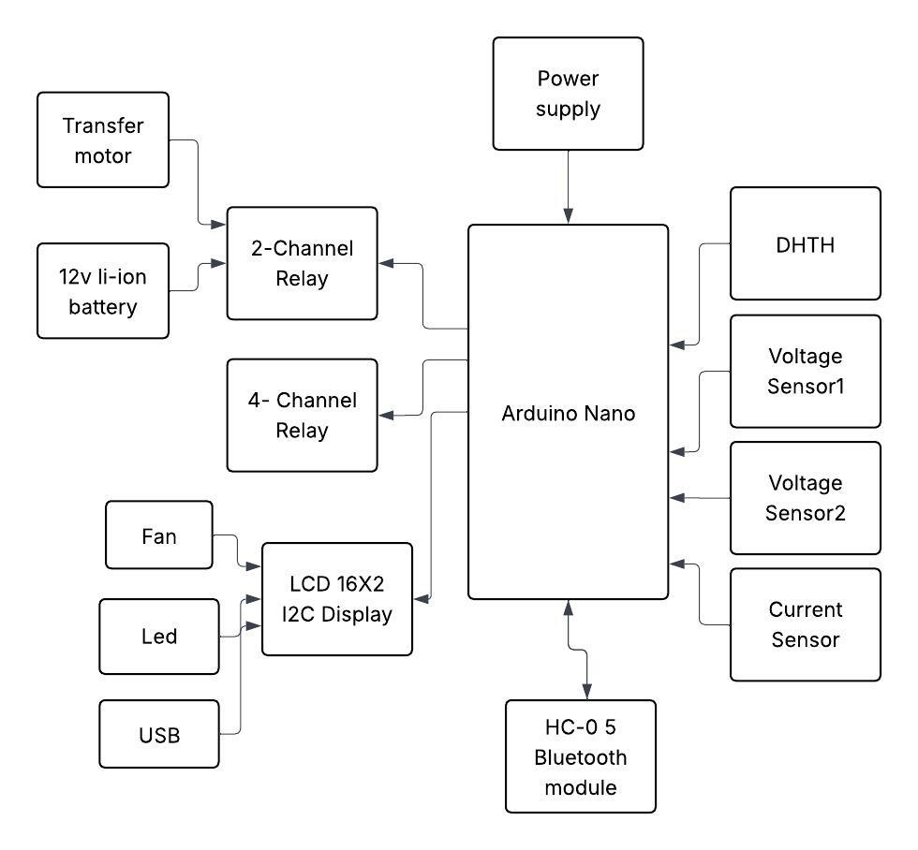
Fig. 1. Overall system architecture of the Smart Microgrid Using Face Authentication System.

B. Hardware Configuration
1) Power Sources:
Transformer - primary source
Li-ion battery - backup source.
2) Sensors:
Voltage sensors detect source levels.
The current sensor monitors load current.
The temperature sensors record temperature and humidity.
3) Control and Actuation:
We need two relay modules, one 2-channel unit for source selection and another 4-channel unit for load control (fan, LED, USB, extra load).
4) Communication:
The serial communication between the Arduino and either a mobile application or a face authentication device was handled by the Bluetooth module HC-05.
5) Show:
A LCD is used to show instantaneous readings of voltage, current, temperature, humidity, and active source.

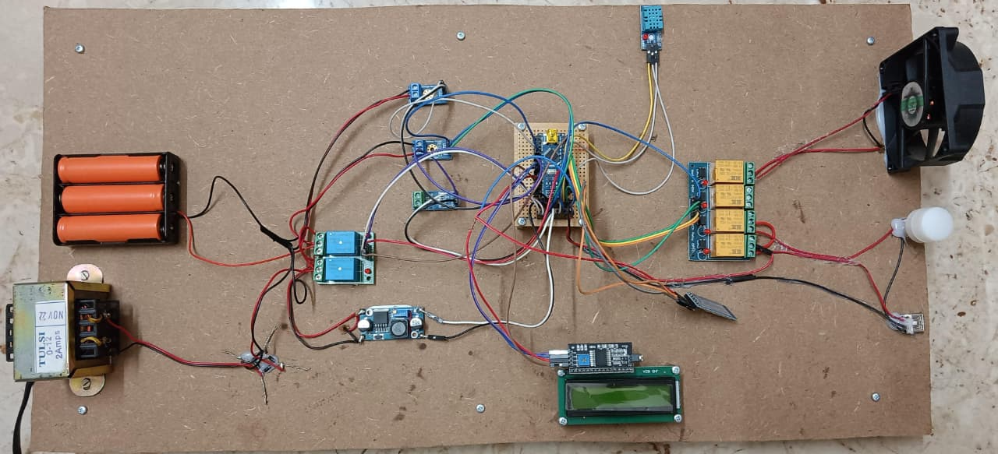
Fig. 2. Hardware implementation layout

C. Software Flow
1. Start and Initialize – Sensors, LCD, and serial ports are turned on.
2. Face Authentication – Captures user's face; control unlocked only after a match.
3. Sensor Readings - Arduino collects voltage, current, and environmental data.
4. Decision Logic – The source with high voltage is selected.
5. Load Control – Authenticated users send commands to operate loads using Bluetooth.
6. Display and Update – All parameters displayed on LCD; cycle repeats every second.
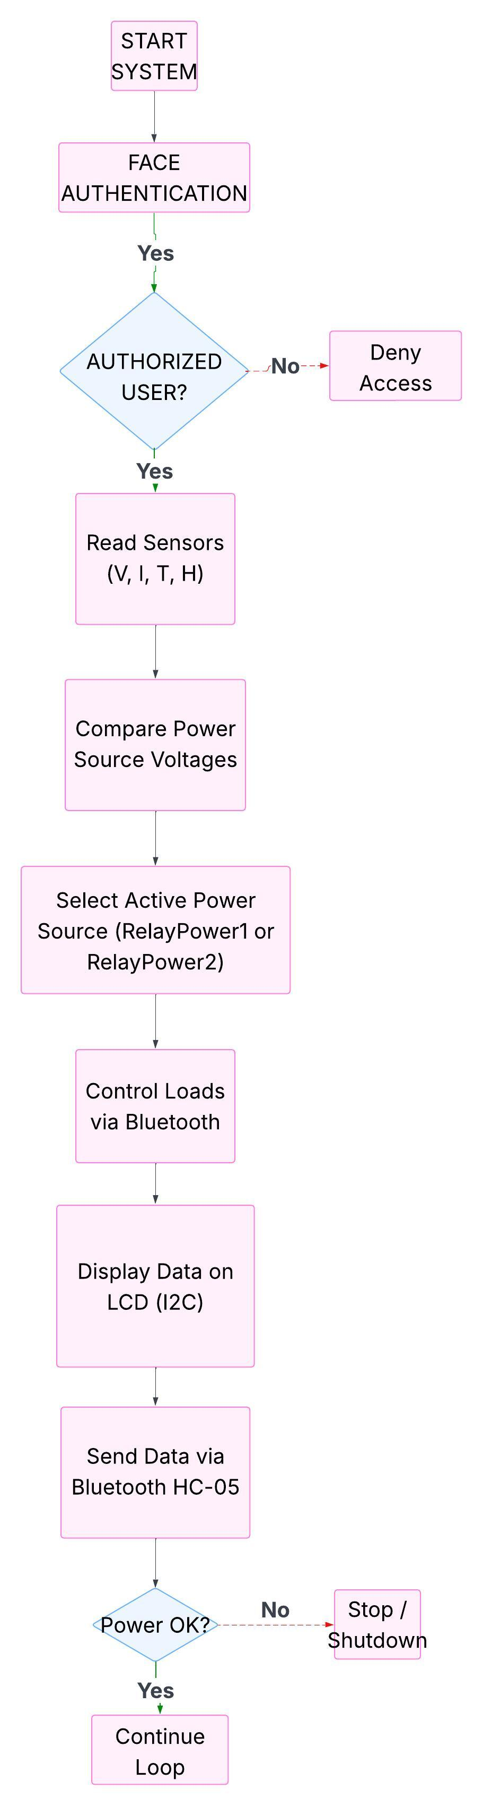
Fig. 3. Software flowchart

D. Circuit Description
The detailed circuit is shown in Fig. 4, where interconnections of the Arduino Nano are made with sensors, relays, a bluetooth module, and LCD display. Voltage sensors are connected to analogue pins A0 and A1, the current sensor (ACS712) is connected to A2, and DHT11 to D2. Relay modules are driven by digital pins D4–D8, while TX/RX pins interface with HC-05. Proper isolation and flyback protection ensure hardware safety.

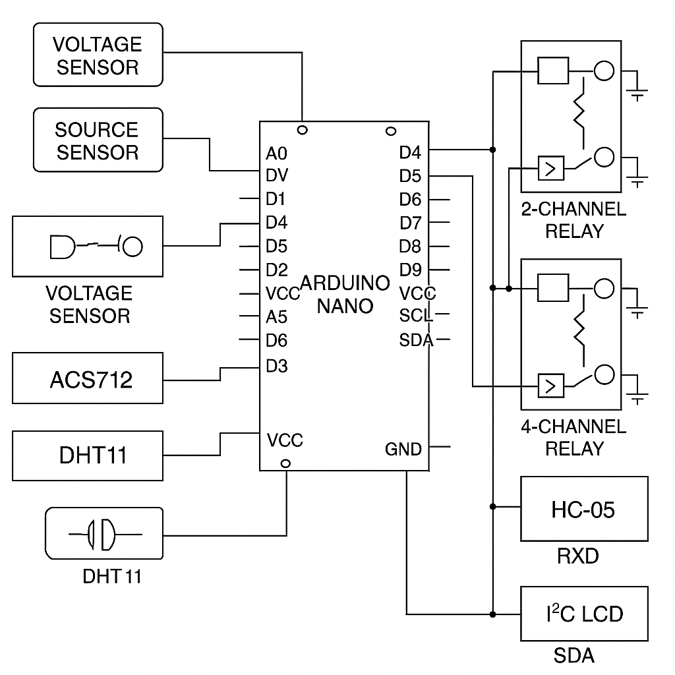
Fig. 4. Circuit diagram

IV. RESULTS and DISCUSSION

A. Experimental Setup
The system was set up using a DC transformer along with a Li-ion battery as the backup source. We connected common household loads like a fan, an LED light, and a USB charger through relays to test how the system switches power. Face recognition was handled by the ESP32-CAM, which was programmed using OpenCV. All the readings were shown on an LCD display, and we cross-checked the values with external measuring instruments to make sure everything was accurate.

Table I
Performance Summary of the Smart Microgrid Prototype
Parameter | Observed Range | Ideal Range | Status
Source 1 Voltage | 11.5 – 12.2 V | 11 – 12.5 V | Stable
Source 2 Voltage | 11.4 – 12.1 V | 11 – 12.5 V | Stable
Switching Latency | 0.25 s | ≤ 0.5 s | Fast
Current Accuracy | ±0.05 A | ≤ ±0.1 A | Accurate
Temperature Range | 26 – 42 °C | 0 – 50 °C | Normal
Humidity Range | 40 – 70 % | 30 – 80 % | Acceptable
Face Auth Accuracy | 96 % | ≥ 90 % | High

B. Key Observations
• The system was able to switch almost instantaneously between sources, taking just 0.3 seconds following the loss of power input.
• Once calibrated, all sensors provided consistent, clean readings without any noise.
• Bluetooth held up well, too, staying reliable up to 10 meters.
• The face authentication system blocked the unauthorized users.
Overall, the system performed almost same like the earlier models from Zubov et al. [6] and Mohammad et al. [7].

C. Discussion
The system combines both automation and biometric control in a single platform. Exams have demonstrated that this type of hybrid approach provides excellent, dependable performance and upholds strict user protection. Still, Bluetooth doesn't reach far enough, and face recognition works only when the lighting is right. Switch to Wi-Fi for better connectivity, use AI-driven image processing to make it more robust. [8], [9].
V. CONCLUSION and FUTURE SCOPE
An economically operated smart grid using the
Internet of Things (IoT) has been developed and
studied in this work. The advanced technology
provides energy operation and analysis in the
microgrid. It automatically selects the best possible power source while continuously monitoring the most needed metrics and it provides access to only to the faces which are recognized. The use of face
authentication helps to gauge different parameters
of smart grid similar as temperature, voltage and inflow of current, which significantly assists in the process of remote monitoring for controlling colourful factors of smart grid. The developed
technology also identifies the demand pattern and
allows the microgrid to supply power and it's
applicable for low demand as well as high
demand. The model is scalable and can be used in smart homes, industries and university labs. Future features could include AI-driven energy management, cloud-based data logging, and renewable sources. The encryption and multi-factor authentication will improve the cybersecurity, by making the system to keep up with today's demands. [2], [5], [9].

References
[1] A. J. Albarakati et al., “Microgrid Energy Management and Monitoring Systems—A Comprehensive Review,” Frontiers in Energy Research, vol. 10, Art. no. 1097858, 2022.
[2] c Khan et al., “IoT-Based Power Monitoring System for Smart Grid Applications,” Processes, vol. 12, no. 2, Art. no. 270, Feb. 2024.
[3] K. E. Ojo et al., "Microgrids' Control Strategies and Real-Time Monitoring," Energies, 2025.
[4] Li, Zhipeng, et al. "Design of smart grid network access system based on face recognition." 2024 IEEE 4th International Conference on Power, Electronics and Computer Applications (ICPECA). IEEE, 2024.
[5] R. Sitharthan et al., “Smart Microgrid with the Internet of Things for Adequate Energy Management,” Energy, 2023.
[6] D. Zubov et al., “PV-Driven Smart Islanded Microgrid: Intelligent I²C Arduino-Based Demand Energy Management,” CEUR Workshop Proc., 2023.
[7] A. S. Mohammad et al., “IoT-MFaceNet: Internet-of-Things-Based Face Recognition Pipeline,” Sensors, 2024.
[8] H. O. Shami et al., "A Novel Strategy to Enhance Power Management in AC/DC Hybrid Microgrids," Energy, 2024.
[9] Murugan, G., and S. Vijayarajan. "IoT based secured data monitoring system for renewable energy fed micro grid system." Sustainable Energy Technologies and Assessments 57 (2023): 103244.

